Glycerol as an Ergogenic Aid
Glycerol is one of the essential nutritional supplements required by athletes to enhance their performance. Despite taking these ergogenic aids supplements to boost performance, most of the not scientific evidence. Consequently, some athletes have faced legal sanctions after testing positive for doping. In any sporting activity, athletes frequently take water if the event is carried out in a high-temperature environment. Consequently, my choice to analyze the use of glycerol as an ergogenic aid is to reasons behind glycerol intake during and after competition or exercise. Besides, this research will focus on addressing the positive impact of this supplement and the negative impacts that learners should be conversant with while taking it. As every athlete yearns to better their performance in their line of sport, understanding the protocol of glycerol intake and the potential side effect is key to maintain better health.
My topic will allow learners to understand the necessity for taking glycerol. According to Kim (2019), athletes should maintain a high level of hydration status before exercise. Typically, taking it is recommended not to take more water once the victim might encounter side effects such as diuresis. Consequently, glycerol is preferred to water as it reduces this problem and increases fluid retention (Kim, 2019). Additionally, taking glycerol minimizes dehydration and limits cardiovascular strain, which might reduce an athlete's performance. Furthermore, when taken before exercise, it reduces heartbeat and increases endurance time (Kim, 2019). Notably, the quantity taken is determined by whether an athlete took glycerol before or during training.
The 7-days awareness will allow students to understand the necessity of glycerol in nutrition. I will collect primary data from soccer players in our institution. The data will include those who take a large volume of water before exercise and those taking glycerol before and during training or competition. For glycerol intake, I will recommend athletes to take 1.2g/kg b.w before exercise. However, those who will have taken it before exercise should only take 0.125g/kg b.w with 5ml/kg b.w fluid. Nevertheless, the soccer players who will not have taken glycerol before exercise will be given 0.4g/kg b.w every four hours of exercise. My analysis will focus on the positive results of glycerol intake and the side effect. According to Kim (2019), athletes taking glycerol are likely to experience side effects such as dizziness, frequent headache, nausea, and gastrointestinal discomfort. Therefore, anyone who will develop these symptoms will be advised to either reduce the dose or avoid taking glycerol during or before exercise.
Days of the Week | Pre-Exercise Intake  (60 minutes) | During Exercise  (Every 4 hours) | Side Effect
Monday | 1.2g/kg b.w | 0.4g/kg b.w
Tuesday | 1.2g/kg b.w | 0.4g/kg b.w
Wednesday | 1.2g/kg b.w | 0.4g/kg b.w
Thursday | 1.2g/kg b.w | 0.4g/kg b.w
Friday | 1.2g/kg b.w | 0.4g/kg b.w
Saturday | 1.2g/kg b.w | 0.4g/kg b.w
Sunday | 1.2g/kg b.w | 0.4g/kg b.w
Table 1: Quantity of glycerol intake by athletes before and during training and side effects, if any, within a week (7 days)
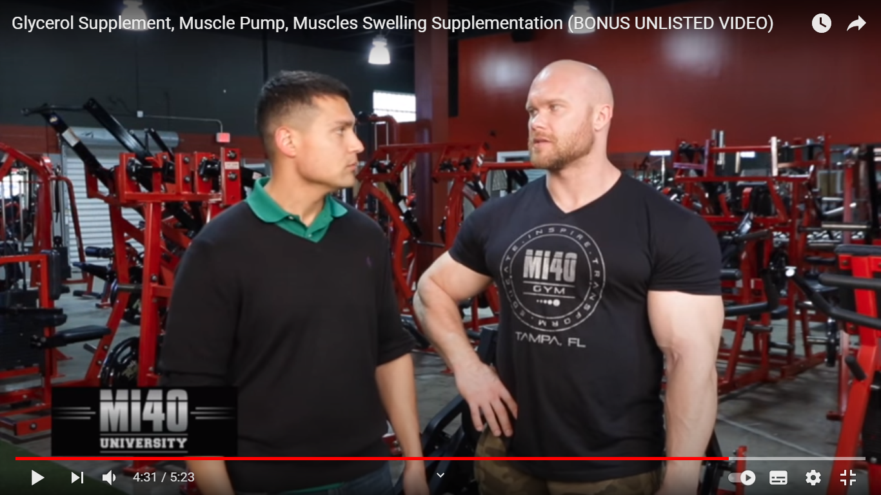
Figure 1: Video showing the impact of glycerol intake. https://youtu.be/fno9IKmSQC4
Every athlete require enough energy to perform adequately, and glycerol plays a significant role in facilitating this process. It helps in reducing dehydration and supplement muscle functionality on parts of the body. Notably, it pulls fluids into the muscle by putting fatty acid into it. Essentially, glycerol intake has an immediate impact on the body of an athlete and will increase performance. Nevertheless, the user should be under the instruction of a professional to limit the side effect to the users.

References
Kim, J. (2019). Nutritional supplement for athletic performance: Based on Australian Institute of sports supplement framework. Exercise Science, 28(3), 211–220. https://doi.org/10.15857/ksep.2019.28.3.211
Pakulski, B. (2015, December 20). Glycerol supplement, muscle pump, muscles swelling supplementation. Www.youtube.com. https://youtu.be/fno9IKmSQC4

